6A History Assignment – Term 2, 2013

Photo Journal – Queensland Parliament
Task Sheet

Task:
- You will have access to a set of images relating to Queensland Parliament. These images can be accessed through the class website.
- Select a total of two images from each group of photographs. You will have a total of six images. Download your selected images onto your computer
- For each image you must prepare approximately 150-200 words of text to teach us about the most important aspects of your chosen image.
Remember to focus on Who, what, when, where, how, why, etc.
- Your project will be presented on A4 paper with the Title and Image at the top of the page and the word-processed text underneath. If your text goes over two pages then that is fine.
- Only use 12-point text in Ariel font. Your line spacing should be 1.5
- Hand in your rough draft as well as your final copy.

Due Date:
Friday 17th May, 2013

Suggested timeline for completing your project:
Week 2 - select your images, research 3 areas. Each area must consist of 150 - 200 words
Week 3 – research final 3 areas. Each area must consist of 150 - 200 words.
Week 4 – prepare rough draft of text, edit and proofread, type out sections with images and titles at the top
Week 5 - finish typing, proofread and edit. Print out good copy for submission.
You may work faster than this if you choose, but not any slower!

The three areas you can choose from:
History
- History of Queensland Parliament House
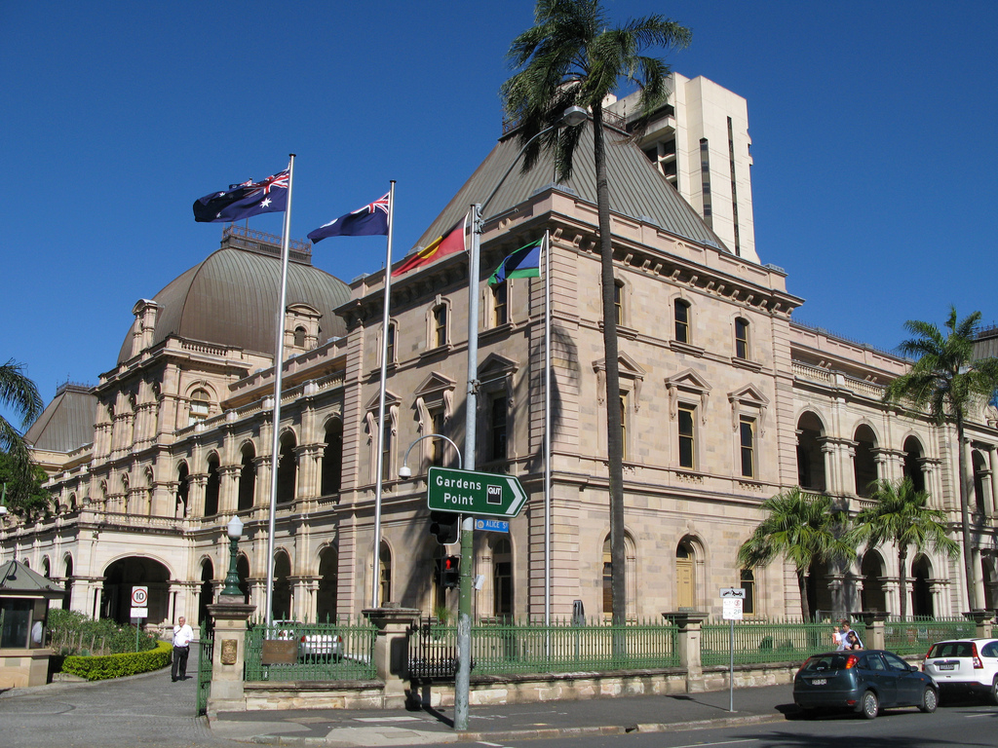
- Qld. Legislative Assembly
- Qld. Legislative Council
- The Westminster system of Government
(select 2 of these images)

Roles and Responsibilities
- Role of the Queensland Parliament Speaker
- Role of the Queensland Clerk of Parliament
- The Queensland Governor
- The Queensland Premier
- The Queensland Cabinet
- The Queensland Opposition Leader
(select 2 of these images)

Traditions and Processes
- Queensland Mace
- Queensland Hansard
- Making Laws in Queensland
- Debating and questioning in Queensland Parliament
(select 2 of these images)

Criteria for Queensland Government Photo Journal Project

Areas of assessment focus | Below expected Year Level | At expected Year Level | Above expected Year Level
Assignment submitted on, or before, the due date
All aspects of the task have been completed as per the task sheet
Use of titles

Quality information prepared for each image

Alignment between draft and final copy

Spelling and punctuation

